**A**

**Summer Internship Report**

**On**

**HRDC Administration**

(CE446 – Summer Internship - II)

**Prepared by**

Dhruv Kava(18CE041)

Jahan Patel(19CE099)

**Under the Supervision of**

Prof. Ashwin Makwana

Prof. Sneha Padhiar

Prof. Kruti Dhyani

**Submitted to**

Charotar University of Science & Technology (CHARUSAT)

for the Partial Fulfillment of the Requirements for the

Degree of Bachelor of Technology (B.Tech.)

**Submitted at**



**Accredited with Grade A by NAAC**

**Accredited with Grade A by KCG**



**U & P U. PATEL DEPARTMENT OF COMPUTER ENGINEERING**

**Chandubhai S. Patel Institute of Technology (CSPIT)**

**Faculty of Technology & Engineering (FTE), CHARUSAT**

**At: Changa, Dist: Anand, Pin: 388421.**

**July 2021**

**Candidate’s Declaration**

I hereby declare that project report titled “HRDC Administration” submitted towards the completion of project in Bachelor of Computer Engineering in CSPIT, Anandis an authenticate record of my work carried out.

I further declare that to the best of our knowledge the report .

|  |  |
| --- | --- |
| First candidates name | **: DHRUV KAVA** |
| Branch | **: CE 7th Semester** |
| Enrollment Number | **: 18CE041** |
|  |  |
| Second candidates name | **: JAHAN PATEL** |
| Branch | **: CE 5th Semester** |
| Enrollment Number | **: 19CE099** |

Guide By : **Prof. ASHWIN MAKWANA**

**Prof. SNEHA PADHIAR**

**Prof. KRUTI DHYANI**

Signature**:**

Submitted to: CSPIT, Anand

Affiliated to: **Charotar University of Science and Technology (CHARUSAT)**

**Abstract**

HRDC Administration is cloud based portal. In this project we are going to develop the php based application which involves academic information about students. In this application, the colleges put all academic stuff like attendance as well as the events and workshop for technical and non technical users. This involves registration of events and workshop, academic activities done by users. And users can register into the event and workshop for taking part in it.

This is all in one application which is includes to record maintains starting from inquiry handling, user registration, till user gets passed out of the course.

This software will help you with managing all day to day college activities easily.

**ACKNOWLEDGEMENT**

I am heartily thankful to my supervisors, Prof. Ashwin Makwana, Prof. Kruti Dhyani , and Prof. Sneha padhiar, whose encouragement, supervision and support from the preliminary to the concluding level enabled me to develop an understanding of the subject. At the end, I offer my regards and blessings to all of those who supported me in any respect during the completion of the project and to our college for providing a resources and materials.

Table of Contents

Abstract i

Acknowledgement ii

Chapter 1 Introduction 1

1.1 Project Summary 1

1.2 Project Purpose 1

1.3 Project Objective 1

1.4 Project Scope 1

Chapter 2 Project Management 3

2.1 Project Planning 3

2.2 Project Scheduling 3

Chapter 3 Summary Requirement Study 5

3.1 User Characteristics 5

3.2 Hardware and Software Requirement 5

Chapter 4 System Analysis 6

4.1 Study of Current System 6

4.2 Problems and weakness of Current System 6

4.3 Requirements of New System 6

4.3.1 Functional Requirement 6

4.3.2 Non-Functional Requirement 7

4.4 Functions of System 7

4.5Data Modeling 9

Chapter 5 System Design 11

5.1 System Procudure Design 11

5.2 Sample of Forms , Reports and Interface 12

Chapter 6 Testing 13

6.1 Testing Plan 13

6.2 Testing Strategy 14

6.3 Test Suites Design 15

Chapter 7 Limitation and Future Enhancement 17

7.1 Limitation 17

7.2 Future Enhancement 17

Chapter 8 Conclusion and Discussion 18

8.1 Conclusion 18

8.2 Discussion 18

References 19

**CHAPTER 1**

**INTRODUCTION**

## Project Summary:

* We are creating HRDC Administration Project which involves registration of users in events and workshops .also this Project useful for admin side, where admin can create & Schedule Event and after this also admin get the details of event, admin get details of participant and also admin can saw all the event and print and create pdf of all this module.
* There are mainly two modules Admin and users.
* In this user module, the colleges suggest the events and workshops for participation of users. This involves registration of events and workshops from different colleges. And users register into events and workshop for takingpart.

## Purpose:

* Purpose of HRDC system is to automate each and every event task of HRDC members, where by using this software they can easily generate their HRDC event and share the event details to teaching ,non teaching and management participants. Software will helps to create central data repository where each event schedule details, participant details, attendence details, expert details will be stored at one end.

## Scope:

* **Manage Events:** this is managed by HRDC Department of college. That is managed by admin side. Keep record of all the events. That is which college has registered events and by which date.
* **Manage Workshops:** College will manage it. They decide that which workshop is organized for particular subject according to users.
* **Manage Users:** users are managed by completing their requirements. By giving response to them. They can login on the portal and be a part of the portal.

## Technology and Literature Reviews:

### Technology:

* **Front end:** HTML, CSS, PHP, xml
* **Back end:** PHP, SQL
* **Tools:** Notepad++, Sublime Text, PHP Myadmin, Xampp

### HTML:

HTML an initialize of Hyper Text Markup Language for web pages .It provides a means to describe the structure of text based information in document by denoting text as headings , paragraphs, lists and so on and to supplement that text with interactive forms, embedded images and other objects.

### JAVA:

In addition, Java is a computer programming language created by James Gosling that is use to build software’s/apps like, Android Studio itself and some other apps .Android Studio is a IDE tool which is used to create Android Apps. The language used to develop an android app is Java

### XML:

Elements in Visual Studio provides integration with Android Studio, Google's official IDE for Android development that is used by Java language developers, to allow you to edit XML Layout Files and other Android-specific XML resource files (such as AndroidManifest.xml or strings.xml ).

**PHP:**

PHP (recursive acronym for PHP: Hypertext Pre-processor) is a widely-used open source general-purpose scripting language that is especially suited for web development and can be embedded into HTML.

### SQL:

SQL (Structured Query Language) is used to perform operations on the records stored in the database such as updating records, deleting records, creating and modifying tables, views, etc. SQL is just a query language; it is not a database. To perform SQL queries, you need to install any database, for example, Oracle, MySQL, MongoDB, Post Gre SQL, SQL Server, DB2, etc.

**CHAPTER 2**

**SOFTWARE PROJECT MANAGEMENT**

2.1**Project Planning and Scheduling**

* Project planning is a procedural step in project management, where required documentation is created to ensure successful project completion. Documentation includes all actions required to define, prepare, integrate and coordinate additional plans. The project plan clearly defines how the project is executed, monitored, controlled and closed.
* Project planning requires an in-depth analysis and structuring of the following activities:
  + Setting project goals
  + Identifying project deliverables
  + Creating project schedules
  + Creating supporting plans

## 2.2 Project Scheduling

* Project scheduling is to a project manager like landing an airplane is to a pilot. It is often the largest and most visible aspect of project management.
* Project scheduling is one of the critical management tasks as it dictates the time frames in which the project will be completed, the budgets/costs in terms of resource requirements and the sequence of tasks to be completed.
* These six processes are performed in chronological order and represent the 6- step process in developing a project schedule.
  + Step 1: Plan **Schedule** Management....
  + Step 2: Define Activities. ...
  + Step 3: Sequence Activities....
  + Step 4: Estimate Activity Resources....
  + Step 5: Estimate Activity Durations....
  + Step 6: Develop Schedule.

## Project development Approach

We have incorporated processes into our methodology to relate strategy to planning and incorporate strategy in plans and provide the means to measure success.

* Planning the work or objectives
* Analysis & Design of objectives
* Assessing and controlling risk
* Allocation of resources
* Organizing the work

The Process Paradigm we used for our project is Incremental Model.

### The Incremental Software Process Model

**Incremental Phases: Activities performed in incremental phases**

Requirement Analysis: Requirement and specification of the software are collected Design: Some High Function are designed during this stage

c

Code: Coding of software is done during this stage

Test: Once the system is deployed, it goes through the testing phase

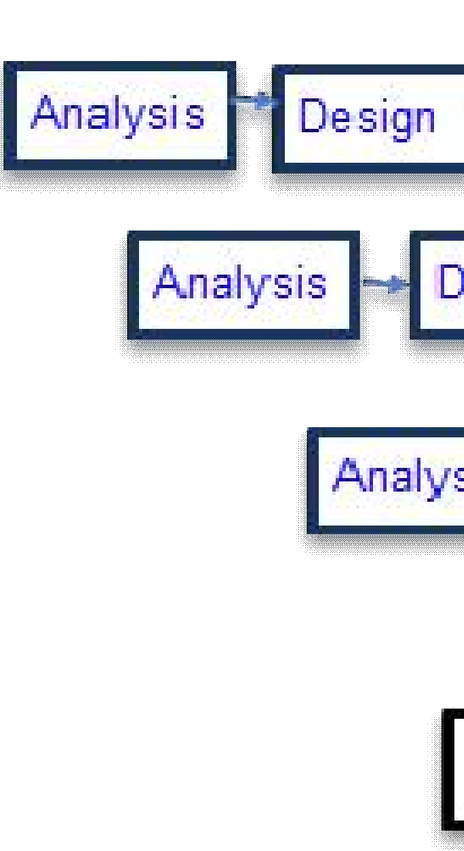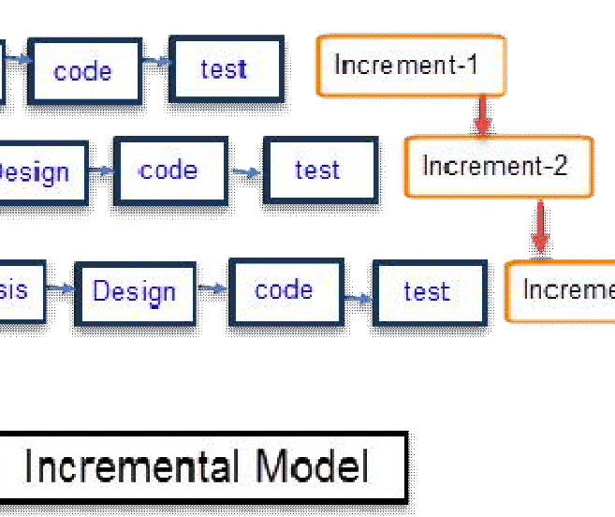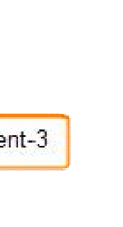

Figure 2.1 Incremental Model

**CHAPTER 3**

**SYSTEMREQUIREMENTSTUDY**

## 3.1UserCharacteristics

* + - It describes the type of user which deals with the applications. Basically, this application has three types of users as given below:

1. Administrator
2. User

### Administrator:

* + Responsibility of administrator is to manage the application database and update the data in database regularly. For e.g. manage the data of vender and water tanks**.**

### User:

* + Once the portal being tasted and being uploaded then after customer (or end user) will use this application. User in the main reason for which this application is being built. The end user can easily interact with the government using this portal.

## Hardware and Software Characteristics

### Hardware Requirements

* + - * Minimum2.27Ghzprocessor
      * RAM: 2GBminimum

### Software Requirements

* + - * Notpad++, Xampp, SublimeText

**CHAPTER 4**

**SYSTEM ANALYSIS**

## 4.1 Study of Current System

* + - Currently that isn’t any Java Web portal that makes governments task easy by adding interactivity and administrative features on the portal.

## 4.2 Requirement of this System

* + - We are developing water tank purification portal. By using this portal, the government’s task becomes easy and they can complete their task of water tank purification in very efficient manner.
    - Currently, this type of concept is not available in market. We are developing our portal on this creative concept.

### 4.2.1FunctionalRequirement:

1 User Requirement:

* + - * User who uses this portal should know how to operate the windows. Because the software has the same look and features like whole software is menu driven.
      * Just click and corresponding thin from menu of hyperlink will be opened.

2 Identification of functional requirement:

* + - * The high level functional requirement often needs to be identified from an informal problem description document or from a conceptual understanding of the problem.
      * Each high level requirement characterizes away of system usage by some users to perform some meaningful piece of work.

3 Documentation of functional requirement:

* For documenting the functional requirement we need to specify the set of functionalities supported by the system.
* A function can be identified the state at which the data to input to the system, its input data domain, the output data domain, and the type of possessing to be carried out on the input data to obtain the output data.

### 4.2.2Non-functionalrequirement

1. Usability
   * + - The interface should use terms and concepts, which are drawn from the experience of people who will make most of the system.
2. Efficiency
   * + - The portal must provide easy and fast access without consuming more cost .Readability
         * User should never be surprised by the behaviour of the system and it should also provide meaningful feedback when error occurs so that user can recover from the error.
3. Accuracy
   * + - * The user should require that data are obtained from database and stored in database must be accurate.
4. Security
   * + - * The user wants the data stored in database must be secured and cannot be accessed by unauthorized user.
5. Maintainability
   * + - * User wants that the system should be maintained easily means that if there are some changes required in the system that can be done easily.

## 4.3RequirementValidation:

* + - Requirement validation examines this specification to ensure that all the system requirements have been statedunambiguously.
    - These inconsistent, error have been detected and corrected and the work products confirmed to the standard.
    - Source of the requirement are identified, final Statement of requirement has been examined by original source.
    - Requirements related to main requirements are founds.
    - Requirements are clarifying stated and are not misinterpreted.
    - All sources of requirements are covered to get a maximum requirement.
    - All method of finding requirements is applied.

## 4.4Function of the System

### Use-Case:

* + - * Use case diagram is primarily made to identify users and their requirements. These can easily be done by creating Use Case diagram. Use Case diagram also helps to identify factors that might influence or change the system.

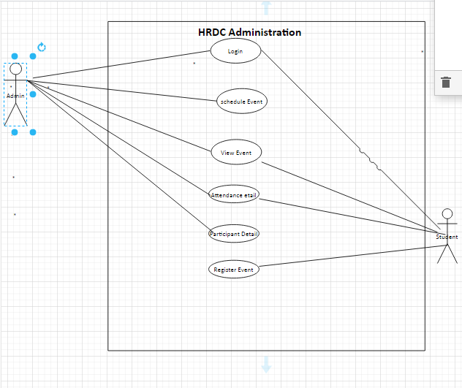

[Figure 4.3 – use-case diagram]

### Sequence Diagram:

* + - * After understanding requirements, entities and relationship between among them, it is very essential to figure out how they interact with each other. These interactions can easily be identified by using sequence diagram. Sequence diagram is used to show interaction between objects. Constructed Sequence Diagram for our given situation is as below. Primarily our sequence diagram consists of 3 objects Admin, Mail Client and Application itself. Admin is responsible to handle all the data on database that is interfaced by the application. Hence, authentication is very much important and due to that first interaction is authentication. Authentication is followed by many of the tasks that an admin might like to perform including sending a mail again this triggers application to contact mail client (e.g. Google) and mail clients may respond with acknowledgement.

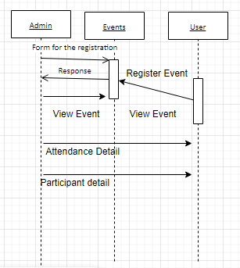

[Figure 4.4 – Sequence diagram ]

**4.5Data Modelling**

### E-R Diagram

* + - * Entity – Relationship Diagram is a first step to identify the entities related to our project and hence, needed to be improved or used optimally. ER diagram helps us to establish relations among entities and how to use them properly

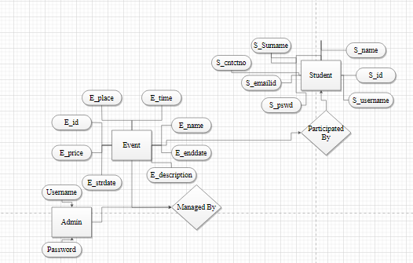

[Figure 4.8 – ER diagram]

### Class Diagram

* + - * In software engineering, a **class diagram** in the Unified Modelling Language (UML) is a type of static structure diagram that describes the structure of a system by showing the system's classes, their attributes, operations (or methods), and the relationships among objects.
      * The class diagram is the main building block of object oriented modeling.
      * It is used both for general conceptual modelling of the systematic of the application, and for detailed modelling translating the models into programming code.
      * Class diagrams can also be used for data modeling.
      * 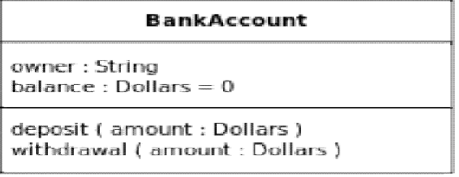The classes in a class diagram represent both the main objects, interactions in the application and the classes to be programmed.

In the diagram, classes are represented with boxes which contain three parts:

* + - * + The top part contains the name of the class. It is printed in Bold, centred and the first letter capitalized.
        + The middle part contains the attributes of the class. They are left aligned and the first letter is lowercase.
        + The bottom part gives the methods or operations the class can take or undertake. They are also left aligned and the first letter is lowercase.

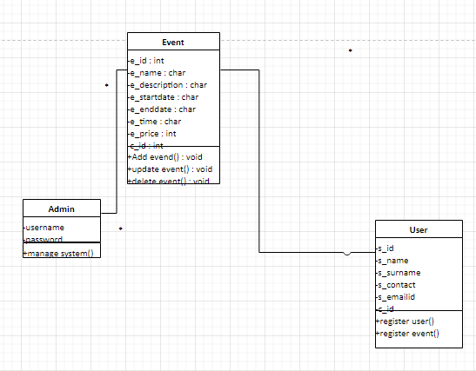

                                                    figure 4.9 – class diagram

**CHAPTER 5**

**SYSTEM DESIGN**

Systems design is the process of defining the architecture, components, modules, interfaces, and data for a system to satisfy specified requirements. The System Design Description report provides summary or detailed information about a system design represented by a model. Systems design is therefore the process of defining and developing systems to satisfy specified requirements of the user.

# 5.1System proce duraldesign:

## Design Pseudo code or algorithm for method or operation:

### Admin side

Step 1: Enter the URL to open the System.

Step 2: Provide User name and Password.

Step 3: if username and password both is correct then it will login successfully.

Step 4: it shows home page

Step 5: admin can be able to Perform Many operations.

Step 6: admin can be able to create the new events and also .

Step 7: event function contains check attendance, check attentiveness, check profile, result update, update schedule

### User side

Step 1: enter the URL to open the system

Step 2: Provide User name and Password.

Step 3: if username and password both is correct then it will login successfully.

Step 4: home page contains many function of the system.

Step 5: this page contains participant function.

Step 6: Also in this page user print their own certificate if their takes part in any event.

## Flow chart:

### Admin:

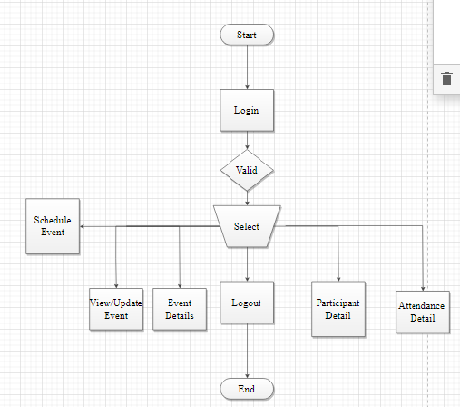

**User:**

[figure 5.1 – Flow Chart]

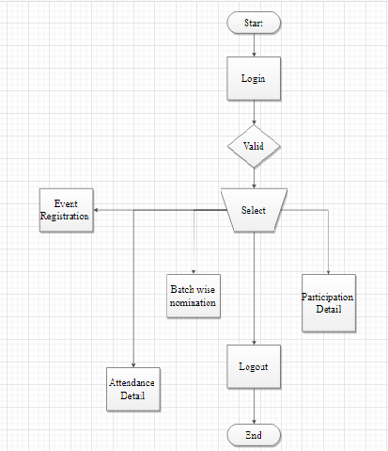

[figure 5.2 – Flow Chart]

**CHAPTER 6**

**Testing**

**6.1 Testing Plan:**

A test plan documents the strategy that will be used to verify and ensure that a product or system meets its design specifications and other requirements. A test plan is usually prepared by or with significant input from [test engineers](http://en.wikipedia.org/wiki/Test_engineer) .Depending on the product and the responsibility of the organization to which the test plan applies, a test plan may include a strategy for one or more of the following:

* **Design Verification or Compliance test:**
* To be performed during the development or approval stages of the product, typically on a small sample of units.
* **Manufacturing or Production test**
* To be performed during preparation or assembly of the product in an ongoing manner for purposes of performance verification and quality control.
* **Acceptance or Commissioning test**
* To be performed at the time of delivery or installation of the product.
* **Service and Repair test**
* To be performed as required over the service life of the product.
* **Regression test**
* To be performed on an existing operational product, to verify that existing functionality didn't get broken when other aspects of the environment are changed (e.g., upgrading the platform on which an existing application runs).

A complex system may have a high level test plan to address the overall requirements and supporting test plans to address the design details of subsystems and components.

Test plan document formats can be as varied as the products and organizations to which they apply. There are three major elements that should be described in the test plan: Test Coverage, Test Methods, and Test Responsibilities. These are also used in a formal [test strategy](http://en.wikipedia.org/wiki/Test_strategy).

**6.1.1The structure of a test plan**

Test plans obviously vary, depending on the project and the organization involved in the testing. Sections that would typically be included in a large system, are:

**The testing process:**A description of the major phases of the system testing process. This may be broken down into the testing of individual sub-systems, the testing of external system interfaces, etc.

**Requirements traceability:**Users are most interested in the system meeting its requirements and testing should be planned so that all requirements are individually tested.

**Tested items:**The products of the software process that are to be tested should be specified.

**Testing schedule:**An overall testing schedule and resource allocation. This schedule should be linked to the more general project development schedule.

**Test recording procedures:**It is not enough simply to run tests; the results of the tests must be systematically recorded. It must be possible to audit the testing process to check that it has been carried out correctly.

**Hardware and software requirements**This section should set out the software tools required and estimated hardware utilisation.

**Constraints**Constraints affecting the testing process such as staff shortages should be anticipated in this section.

**System tests**This section, which may be completely separate from the test plan, defines the test cases that should be applied to the system. These tests are derived from the system requirements specification.

**6.2 Testing Strategies:**

* A **test strategy** is an outline that describes the testing approach of the [software development cycle](http://en.wikipedia.org/wiki/Software_development_process). It is created to inform project managers, testers, and developers about some key issues of the testing process. This includes the testing objective, methods of testing new functions, total time and resources required for the project, and the testing environment.
* Test strategies describe how the product risks of the stakeholders are mitigated at the test-level, which types of test are to be performed, and which entry and exit criteria apply. They are created based on development design documents. System design documents are primarily used and occasionally, conceptual design documents may be referred to. Design documents describe the functionality of the software to be enabled in the upcoming release. For every stage of development design, a corresponding test strategy should be created to test the new feature sets.

**6.2.1 The V-model of software development:**

The so-called V-model of software development relates different stages of testing to activities in the software process. For each stage in the software process, there is a related testing activity. This is shown in Figure 1. The V-model is used in tightly controlled development processes, such as those used for safety-critical systems.

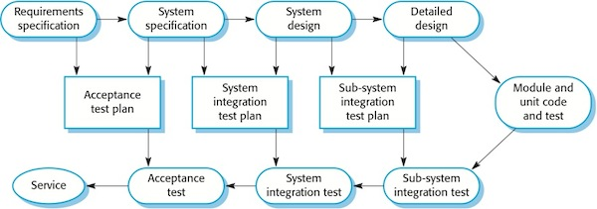

**Figure 6.1The V-model of software development**

**6.3 Testing Methods:**

There are different methods which can be use for Software testing. This chapter briefly describes those methods.

## 6.3.1 Black Box Testing:

* The technique of testing without having any knowledge of the interior workings of the application is Black Box testing. The tester is oblivious to the system architecture and does not have access to the source code. Typically, when performing a black box test, a tester will interact with the system's user interface by providing inputs and examining outputs without knowing how and where the inputs are worked upon.

## 6.3.2White Box Testing:

* White box testing is the detailed investigation of internal logic and structure of the code. White box testing is also called glass testing or open box testing. In order to perform white box testing on an application, the tester needs to possess knowledge of the internal working of the code.
* The tester needs to have a look inside the source code and find out which unit/chunk of the code is behaving inappropriately.

## 6.3.3 Grey Box Testing:

* Grey Box testing is a technique to test the application with limited knowledge of the internal workings of an application. In software testing, the term the more you know the better carries a lot of weight when testing an application.
* Mastering the domain of a system always gives the tester an edge over someone with limited domain knowledge. Unlike black box testing, where the tester only tests the application's user interface, in grey box testing, the tester has access to design documents and the database. Having this knowledge, the tester is able to better prepare test data and test scenarios when making the test plan.

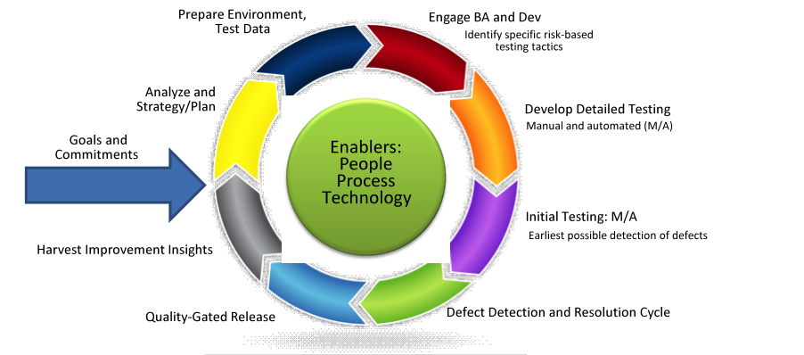

**[6.2] Testing Model**

**CHAPTER 7**

**Limitation &Future Enhancement**

**7.1 Limitation of Project:**

* Though there are clearly many good reasons to utilize our system, there are also disadvantages to consider:
* Our system may complicate simple register events and workshops.  While using our system is a popular option for many organizations, simpler events and workshops.
* Execution issues when relying on automated alerts.  While alerts are helpful to remind team members that tasks are due, a problem develops when more time is spent on setting up the alert than the task itself
* It can run only on windows servers. It is not compatible with LINUX servers.
* Only Specific admin can show and edit the details.

**7.2 Future enhancements**

* In future if we get a chance to work on the same project then we like to improve our system by adding new features depending on user requirements.

**CHAPTER 8**

**Conclusion & Discussion**

**8.1 CONCLUSION:**

* We have learnt how to do interaction between different colleges and students without wondering for mouth to mouth publication of events and workshops.

**8.2 DISCUSSION:**

* This system is made for all the users so that user can see the required information at the website also in his/her own hand. So, the main goal of portability and mobility gets achieved by this application.
* Further, this application is made using Jsp Servlet & hibernate which is leading Microsoft application programming technology. Hence, this application is also economic solution for the user.
* Now, this is a user friendly website so, any user can use this website to buy and sell different products. Therefore, this application provides collaborative interface to the users.

**References:**

* 1. <https://play.google.com/store/apps/details?id=college.erpsoftware.app&hl=en>
  2. <https://www.jnu.ac.in/hrdc>
  3. <https://hrdc.gujaratuniversity.ac.in/hrdc-function>